**Mathematics Methods Unit 4**

# Investigation 2: The usefulness of logarithms

Name: ____________________

Validation: Week 17 Thursday 7th of June

* *The Out of Class Investigation is designed for you to learn the essentials needed for the In-Class validation.*
* *This is the “Take Home” part of the Investigation. It does not count towards your mark for this investigation.*

The following chart shows the loudness levels, some of which can damage the human ear.

|  |  |  |
| --- | --- | --- |
| Chart of sound intensity levels (loudness)for environmental noise | | |
|  | Weakest sound heard | 0 dB |
|  | Rustling leaves | 10 dB |
|  | A whisper in library at 2 m | 30 dB |
|  | Converation at home | 50 dB |
|  | Conversation in restaurant | 60 dB |
|  | Passenger car at 80 kph at 6 m | 70 dB |
|  | Vacuum cleaner at 1m | 70 dB |
|  | Freeway at 20 m | 73 dB |
|  | Telephone dial tone | 80 dB |
| At 90 - 95 dB sustained exposure may sustain hearing loss | Car wash at 6 m | 90 dB |
| Train whistle at 150 m | 90 dB |
|  | Hand drill | 98 dB |
|  | Lawn mower at 1M | 105 dB |
|  | Motorbike | 100 dB |
|  | Jet take off at 300 m | 100 dB |
|  | Sand blasting | 115 dB |
| Threshold of discomfort | Thunderclap | 120 dB |
|  | Chain saw | 120 dB |
|  | Oxygen torch | 120 dB |
|  | Loud rock concert | 115 dB |
| Pain threshold 130 dB | Pneumatic riveter | 125 dB |
|  | Aircraft carrier deck | 140 dB |
| Eardrum rupture | Jet take off at 25 m | 150 dB |

The reference level of the intensity of sound, *I*that all others are compared to is 10 -12 watts/m 2. It was chosen because it is the weakest intensity of sound that can be detected by the human ear.

Intensity, *I*  so *I* is measured inwatts/m 2.

*I* = 10 -12 watts/m 2.

The most intense sound that is not painful to humans is roughly10 watts/m2. Since the human pain threshold at 10 watts/m 2 is 10,000,000,000,000 times greater than the reference level, it makes sense to use a logarithmic scale to discuss the intensity of sound, *I.* The sound intensity level, *L*, is a logarithmic measure given as

*L* = 10 log $\left( \frac{I}{I_{0}}\right)$ and is measured in decibels (dB).

|  |  |
| --- | --- |
| The lowest sound heard by man is | The loudest sound heard without pain (ie. the pain threshold) is 10 watts/m2. |
|  |  |

**Question 1**

Show that the pain threshold is 1013 times more intense than the lowest sound heard by man.

**Question 2**

1. What is the sound intensity level that corresponds to a sound that has an intensity of 10-2 watts/m2?
2. What sound could this be from the table?

**Question 3**

1. How many times more intense is the sound of a loud rock concert than the sound of a conversation at home?

Hint : Find 

b) How many times more intense is the sound of a conversation in a restaurant than the sound of a conversation at home?

**Question 4**

Determine the intensity in watts/m 2 of the following sounds

(a) (i) a chain saw (ii) a vacuum cleaner at 1m

(iii) rustling leaves (iv) a telephone dial tone

(v) a hand drill (vi) an aircraft carrier deck

(vii) the ticking of a watch with a sound intensity level of 20 dB

b) Explain the reason for using sound intensity levels in decibels rather than intensity in watts/m 2*.*

**Question 5**

Use the semi – logarithm graph paper (one axis has a logarithmic scale) to plot some of the intensities of the sounds in **Question 4** against their sound intensity levels and comment on the shape of the graph.

What is the advantage of using this graph paper for the data from Question 4?

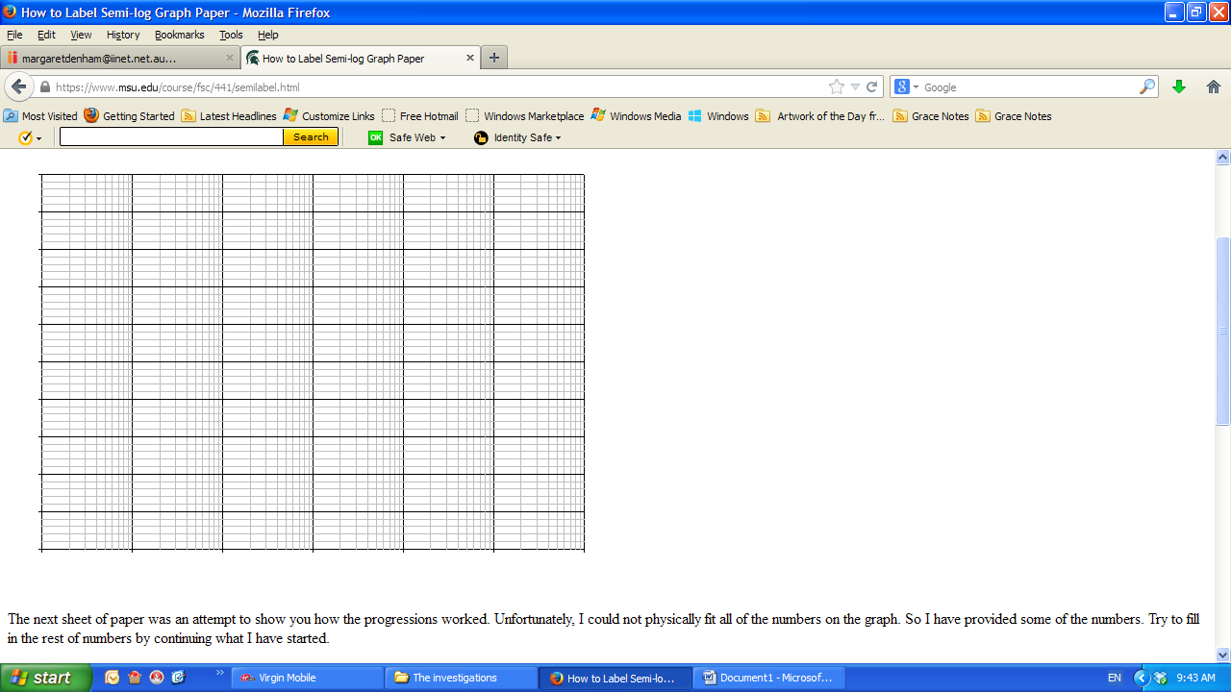

10

1

0.10000

Intensity of

sound ( *I* )

0.01000

0.00100

0.00010

0.00001

50 60 70 80 90 100 110 120 130

Sound intensity level (*L*) Decibels

Semi-logarithm graphs are useful when graphing data that increases exponentially. For example, a population of rabbits that is doubling every year.

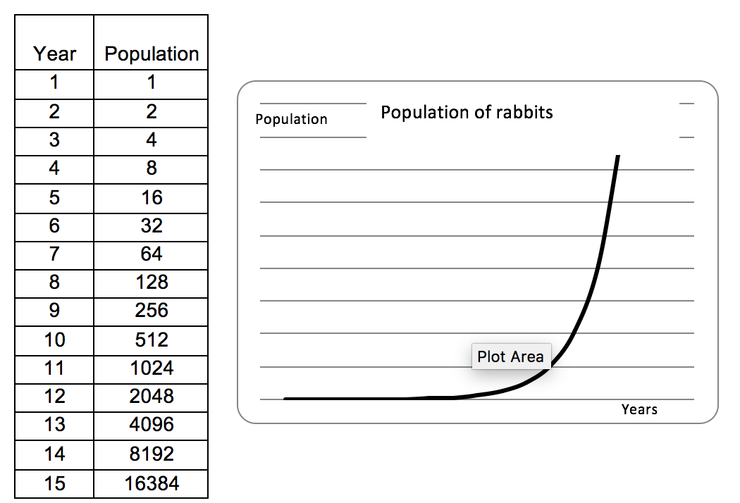

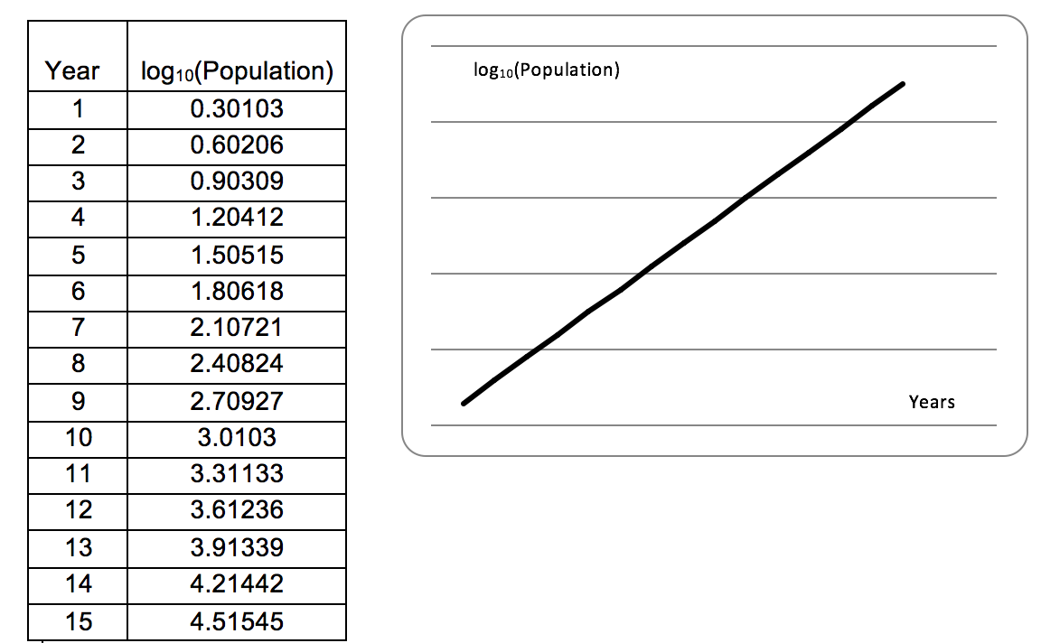

**If the function is exponential, then using semi-logarithm paper makes the graph linear.**

**Question 6**

Show that if the function is exponential, say y = A(b)t  then the function logc(y) graphed against t is linear.